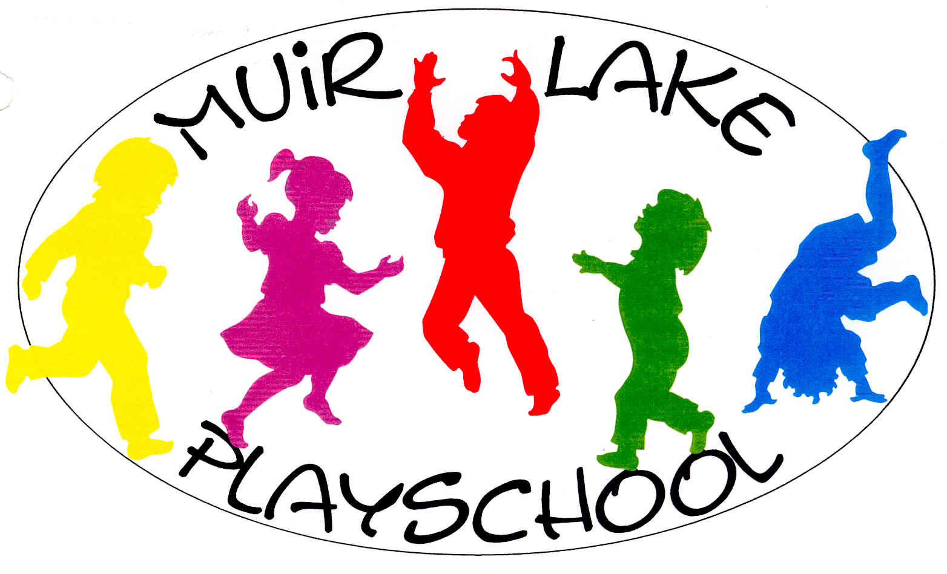

Muir Lake Playschool Association
Mailing address: P.O. Box 2863, Stony Plain, AB T7Z 1Y3
Physical address: 53424 AB 779, Parkland County, T7Z 0A2
Phone: (780) 963-5512
Email: President.MLP@outlook.com
Website: www.muirlakeplayschool.com



PARENT HANDBOOK
2024 – 2025

TABLE OF CONTENTS
GOALS AND OBJECTIVES 3
3-year-old classes (4 hours per week) 4
4-year-old classes (6 hours per week) 4
ILLNESS POLICY 6
DROP OFF AND PICK UP POLICY 6
When dropping off 6
When picking up 7
SPECIAL HELPER DAY 7
Things to remember for your Child’s Special Helper Day 7
Snack suggestions 7
VOLUNTEERING 7
POTENTIAL VOLUNTEER OPPORTUNITIES 8
Fire drills 8
Licensing, Insurance and Health & Safety 9
WEEKLY EMAIL 9
PRE-REGISTRATION AND OPEN HOUSE 9
LATE PAYMENTS 10
WITHDRAWALS 10
CALENDAR OF EVENTS 10
Volunteer opportunities 10
Regular event dates 10
IMPORTANT CONTACT EMAILS 10

WELCOME
Thank you for considering Muir Lake Playschool for your child. Included in this registration package is information about our Playschool philosophy, as well as a list of classes offered, tuition fees, important dates and other commitments required. Should you have any other questions, please feel free to contact us.

MISSION
Our mission is to inspire curiosity, develop independence, foster lifelong learning, and to encourage imagination through play.

PHILOSOPHY
Muir Lake Playschool strives to provide a safe, nurturing, and accepting environment where our unique students are encouraged to develop social, emotional, cognitive, and motor skills through play, at their own pace. We endeavour to add to the development of positive self esteem and independence, as well as encourage the desire to learn and explore through our play orientated program.

GOALS AND OBJECTIVES
- Building Social Skills
- learning appropriate behaviour for different situations;
- learning about conflict resolution using words (e.g. saying sorry, asking for help);
- sharing and taking turns;
- listening, joining in, being friends;
- participating in discussion and group activities.

- Encouraging Independence
- can comfortably separate from parents;
- completing tasks with minimal intervention;
- putting on their own shoes and dressing themselves for outside;
- being responsible for their own actions.

- Building Confidence
- numerous crafts and physical activities aimed at easy mastery to foster a sense of accomplishment, self-confidence, and self-esteem;
- Special Helper Day with Show and Tell, and helping the teachers.

- Having Fun
- getting along and enjoying themselves in a variety of settings.

- Exposure
- learning to use and enjoy a wide variety of art and craft mediums, games, and activities;
- developing classroom skills such as sitting still, listening to direction, and completing an assigned task;
- introduce children to the ABC’s, numbers, shapes, colours and nursery rhymes;
- learning themes throughout the year (e.g. Dinosaurs);
- field trips throughout the year;
- story time to assist with listening skills.

- Physical Activity
- maintaining a moderate level of physical fitness acquired through activities in the community hall and outside (weather permitting).

MUIR LAKE PLAYSCHOOL
Muir Lake Playschool is a non-profit organization managed by a team of parent volunteers who form an Executive Committee. There are 2 teachers in each class. Volunteer opportunities and tuition fees are integral to the success of the Playschool, and a positive experience for our children.

The Playschool offers different themes throughout the year that expose our children to many mediums, while incorporating our goals and objectives. Field trips, outside activities, concerts, and visits by local organizations are also part of our Playschool experience.

The Playschool is part of the Muir Lake Community and has been operating for over 40 years. We offer 3-year-old, and 4-year-old classes. The maximum class size is 16 students. Under special circumstances, the Muir Lake Playschool Executive Committee may change the final class size as deemed necessary. If a class does not have a minimum of 12 children in September, that class may be cancelled at the discretion of the Executive Committee.

The Playschool operates from early September until mid-June. We follow all holidays on the Parkland School Division calendar, including Personal Development days. Parents will be contacted if classes are cancelled due to unforeseen circumstances.

CLASSES OFFERED

3-year-old classes (4 hours per week)
- Tuesday and Thursday mornings from 9:00 am – 11:00 am

4-year-old classes (6 hours per week)
- Tuesday and Thursday afternoons from 11:30 am – 2:30 pm
- Wednesday and Friday mornings from 9:00 am – 12:00 pm

PLAYSCHOOL EXECUTIVE COMMITTEE
A committee of volunteer parents function as the Executive for the Muir Lake Playschool Association. They are responsible for the overall operations of the Playschool. The elections for Executive Committee positions are held during the Annual General Meeting.

OUR TEACHERS
Our teachers are Miss Amanda Turvill and Mrs. Michelle Herman.
Miss Amanda has her Level 3 Certificate in Early Childhood Development, First Aid, and CPR Certificates. She has been an early childhood educator for over 20 years. She has spent time teaching in several provinces and overseas within a variety of early education settings. She loves working with preschool aged children and tries to incorporate the best of all of her experiences into her teaching style. She is a firm believer in learning through play and empowering preschoolers to express their own feeling and make their own decisions. She has been a part of the teaching team at Muir Lake since 2018.
Mrs. Michelle has her Level 2 Early Childhood Development, First Aid, and CPR Certificates. She has been an early childhood educator for over 10 years. She thoroughly enjoys the various personalities and funny perspectives on life of children she works with. Watching her own children grow from playschool age to teenagers has given her a different viewpoint on early childhood development. Mrs. Michelle has been a part of the Muir Lake Playschool teaching team since 2012.

STUDENT INFORMATION
- We welcome 3-year-olds at any time into our program, provided they are 3 years old prior to attending.
- Children must be toilet trained. If an accident should occur during class, a courtesy call will be made to the parents. If an accident occurs during class, and an appropriate change of clothes has not been provided, a parent will be required to pick up their child. If ongoing accidents should occur, a plan will be discussed with the parents on an individual basis. If you have any concerns with this policy, please discuss with one of the teachers.
- The Playschool can administer medication, if necessary, when an Individual Record of Medical Administration is completed prior. This medication will be kept in an area away from children access.
- Dress your child appropriately for the weather, as outside play is encouraged.
- Please dress your child in play clothes, as we paint, use glue, and roll around on the floor!
- Please do not allow your child to bring toys or candy to school. They will be allowed to bring something on their Special Helper Day.

REQUIRED SUPPLIES
- Backpack (that your child can carry)
- Change of clothes (including season appropriate underwear, socks, pants and shirt)
- Indoor running shoes (to be left at the Playschool, please no slippers)
- Box of Kleenex (to be left at the Playschool)
- Approximately 5-10 family photos (including all family, grandparents, pets, etc.) for family tree project. These can be handed in or emailed to Teachers.MLP@outlook.com Note: The photos will be cropped and glued, thus not returned in their original form.

CHILD MANAGEMENT POLICY
We encourage students to problem solve independently with teacher supervision. Where a child’s behaviour needs correction, our procedure is as follows:
- A discussion takes place with the child.
- Child may be removed from situation; a follow-up conversation takes place with the child before he or she is permitted to re-join the group/activity.
- Where the problem involves another child, apologies are encouraged to be made, and choices are given before re-joining the class.
- If the problem involves a toy or piece of equipment, distraction to another activity, or removal of the toy may be helpful.

Out of respect for the children in our program, we will not inflict any form of physical punishment, verbal or physical degradation, or emotional deprivation. We will not deny or threaten to deny any basic necessities. We will not use any form of physical restraint, confinement, or isolation.

ILLNESS POLICY
- Please keep sick children at home! Should your child fall ill during class the teachers will use your contact list beginning with parents to arrange for your child to be picked up from class. In the meantime, they will be kept as comfortable as possible by one of the teachers.
- If your child is not immunized, you will be asked to sign the “Conscientious observer” form at registration. Please be advised you will be asked to keep you child at home if there is an infectious disease outbreak and they will need to remain at home until the risk has passed. Regular fees will apply during this time and a 30-day notice of withdrawal will still be required if you choose to remove them from the program.

Children should be kept home from school if …
- They have had a fever (38.0 higher) or diarrhea in the past 24 hours.
- They have been given medication like Tylenol. Advil, Motrin, Gravol or Benadryl in the past 12 hours.
- They have a new unexplained rash or skin condition.
- They have green, yellow, or excessive mucus coming from nose, eyes or ears that is impeding their ability to play or follow the classroom routine.
- They have started a new antibiotic in the past 24 hours.
- They have a new or strong persistent cough that is impeding their ability to play and participate in the daily routine.
- Unusual behaviours for that child e.g., extreme lethargy, persistent crying, extreme irritability, difficulty breathing or wheezing.
- They have Lice, Scabies, or other infestation. They must remain at home until the proper treatment is fully completed.
We fully expect children to get colds or illness over the course of the year despite our best efforts following the Alberta health guidelines in disinfection, cleaning, and good hygiene practises. A slightly runny noes, a cough that just won’t go away or a child that just a little “off” does not necessarily mean that child needs to remain home from school. If your child does not fall under the stipulations above and is able to fully participate in all the classrooms routines which include, snack, play and outdoor time they are probably fine to attend class. The teachers reserve the right to refuse entry to any child or parent who appears excessively ill or is exhibiting any of the symptoms listed above.

DROP OFF AND PICK UP POLICY

When dropping off
- The door will be opened 5 minutes prior to class.
- Parents are required to drop their children off at the Hall doors, and ensure they are handed off to a teacher.
- Children will be asked to hang coats up and leave all outdoor footwear downstairs in the coatroom.

When picking up
- Due to the limited time between and after classes, please be at the school 5 minutes prior to the end of your child’s class. The children will be brought downstairs at the end of class.
- The teachers will be available to speak with parents and answer any questions at that time.
- If you are more than 10 minutes late picking up your child, a $25.00 fee will be applied.

Please do not drop your child off early or pick up your child late from class. Teachers are using the time before and between classes to prepare the lesson plan and crafts for the next class.

SPECIAL HELPER DAY
This is a very special day for your child, as they get to bring a snack and drink, set the table for snack time, and perform special helper duties all class. They can also bring one special item for “Show and Tell”. A Special Helper Calendar will be emailed monthly to the parent contact, posted on Seesaw and handed out to parents. Please note your child’s scheduled day. If your child cannot attend, it is your responsibility to switch days with another family.

Things to remember for your Child’s Special Helper Day
- You are responsible for providing the snack for this particular class (food and drink)
- All food should be provided to the Playschool prepped and ready to go. Anything that is minimal prep for the Teachers, pre-packed and/or easily distributed is recommended.

Snack suggestions
- Individual drink boxes, yogurt drinks
- Cheese, veggies, dip, fruit, crackers, dry cereal, fruit bars, granola bars, yogurt tubes, etc.

If you forget your snack, the Playschool will charge a fee of $20.00
On your child’s birthday, you can bring in a special treat for the class if you wish.

For the safety of all children at the Playschool, we are nut free. If there are additional food allergies in your child’s classroom, those will be communicated.

VOLUNTEERING
Muir Lake Playschool is a non-profit organization. School fees and funds raised from fundraising events pay for all the costs of running our Playschool program. Fundraising events that require a parent volunteer commitment are an important component of our program and necessary to retain our eligibility to apply for and obtain government grants. The money is used for new initiatives and necessary items for the Playschool. Parental volunteering is integral to making these events a success.

Every year there are two (2) annually scheduled fundraising events, bingos and every three years we have a casino. Parents are required to participate in at least two annual fundraising events.
These are critical fundraising events, and we must have all positions filled to help out. Sign-up sheets will be available at the August Registration Night event as well as emailed out to parents.
The types of events may change based on the requirements of the Playschool and change at the discretion of the Executive. Any changes will be communicated to the Playschool families with plenty of notice.

Important – A $300 volunteer deposit will be taken at the August Registration Night (or after with late registrations) and deposited. The deposit will be returned to you at the end of the school year in June 2025 if you have completed your volunteer shift requirements.

POTENTIAL VOLUNTEER OPPORTUNITIES
- Bingo
The Muir Lake Playschool Association is part of the Muir Lake Community League, and as such is required to work one Bingo each year in support of the Community League. We at the Muir Lake Playschool also have our own Bingos to fill. They are held at the Spruce Grove Bingo Hall throughout the school year.
- Requires 11 people per bingo. It is helpful to have previous Bingo or Cage experience, but it is not required.

2. Pancake Breakfast with Santa
Our Annual Pancake Breakfast is held at Muir Lake Community Hall and usually occurs around the start of December. The date will be communicated to the Playschool family members once confirmed. We bring in a photographer and Santa visits.
- Requires approximately 8 people.

3. Ladies Night
Each year the Executive Committee and Teachers put on a Ladies Night Event. It is a very popular community event and all the funds received go back into the Playschool.
- Requires 4 people for set-up the night before.

4. Casino
Every 3 years, the Playschool will have a Casino. One parent per child will need to work one shift at the Casino in St. Albert. Our next scheduled casino is in the Fall of 2025.

*Please note that for all volunteer opportunities, you can opt to have someone else complete the volunteer requirement in your place (i.e. a family member or friend). You can also decide to opt out of the volunteer requirement, and we will use your volunteer cheque to pay for someone to fill your bingo and/or casino volunteer spot(s).

GENERAL INFORMATION

Fire Drills
Fire drills will be held on a regular basis throughout the school year. It is imperative that your child has proper indoor shoes (no slippers). In addition to the main entrance, there is an emergency fire escape located to the right of the bathroom.

Licensing, Insurance and Health & Safety
The Muir Lake Playschool is licensed by Alberta Child Services, regularly inspected by Alberta Health Department, with an up-to-date Health Inspection Certificate located in the kitchen and is insured through Parkland County.
Please note that the Muir Lake Community Hall is a NON-SMOKING facility.

WEEKLY EMAIL
An update will be emailed to the parent contacts on a weekly basis and will be sent on the Sunday/Monday of that week. The new monthly calendar will also be sent out prior to the start of the new month. Please take the time to read these emails and calendar as they are designed to keep you informed of activities, events, and other related information, such as days off, scheduled field trips, special class days, etc.

PRE-REGISTRATION AND OPEN HOUSE
Priority will be given to returning families, provided the family is a member in good standing as per the Bylaws of the Muir Lake Playschool Association. To secure their spot, we strongly suggest you attend the Pre-registration and Annual General Meeting (AGM) to secure your spot as it is on a first come, first serve basis. This meeting is held in the Spring of each year.

SCHOOL FEES AND VOLUNTEER DEPOSITS
- School fees may be made in full at time of registration by cash, post-dated cheques, e-transfers and by credit card (user fee applies). Cheques MUST be made payable to Muir Lake Playschool Association.
- The $300 volunteer deposit must be made at Registration. This amount will be taken at the beginning of the year and reimbursed at the end of the year if you have fulfilled your volunteer requirement.
- Muir Lake Playschool is part of the Muir Lake Community League (MLCL), and each family must purchase a Community League membership in order to enrol your child in the Playschool.

Total Fees for 2024/2025 School Year
Classes | 3-year-old Class  Tuesday and Thursday AM | 4-year-old Classes  Tues/Thurs PM and Wed/Fri AM
Non-Refundable Deposit | $150 | $150
Volunteer Deposit | $300 | $300
Per Month Cost x 10 months | $35/month (or $350/annually) with the Alberta Affordability Grant in place | $50/month (or $500/annually)  with the Alberta Affordability Grant in place
Total For The Year: | $800 ($300 will be reimbursed to you in June 2025 if your volunteer requirements are fulfilled) | $950 ($300 will be reimbursed to you in June 2025 if your volunteer requirements are fulfilled)
NOTE: THERE WILL BE A $35.00 FEE ON ALL NSF CHEQUES.

LATE PAYMENTS
Monthly fees are due on the 1st day of the month. If payment is late, you will be granted a grace period of 1 week. If payment has not been received by the 7th, you will be given written notice and expected to clear up the late fees prior to your child returning to the classroom.

If late fees are a continual concern, we may require you to pay for the remaining term of the school year.

If your personal circumstances prohibit you being able to do so, please contact our Treasurer and we will work with you to come up with a solution.

WITHDRAWALS
If you wish to withdraw your child from the Playschool, you must provide one month’s written notice. All refunds will be assessed by the Executive Committee to determine if eligible. Volunteer obligations must be met, or the deposits will be forfeited; a withdrawal fee may be applied. The Executive Committee will determine the appropriate fee in these instances, and act according to a majority vote.

CALENDAR OF EVENTS

Volunteer Opportunities
- Bingo – TBD
- Pancake Breakfast with Santa – Saturday December 7th, 2024
- Ladies Night – Saturday March 1st, 2025

Regular Event Dates
- September start date - Tuesday September 10th, 2024
- December end date - Friday December 13th, 2024
- Christmas Concert – December 13, 2024
- January start date – Tuesday January 7th, 2025
- June end date / Year End Party - Friday June 13th, 2025

IMPORTANT CONTACT EMAILS
President – President.MLP@outlook.com
Treasurer – Treasurer.MLP@outlook.com
Teachers – Teachers.MLP@outlook.com

